

**CAMPUS MUNCHIES**

**fast food management system**

**Final Release Document**

– CanTho, Nov 2023 –

**Table of Contents**

I. Deliverable Package 3

II. Installation Guides 3

III. User Manual 3

1. Overview 3

2. Order food for customer 4

3. Analytic for Managers 8

4. Change status order for Customer 11

# I. Deliverable Package

| **No.** | **File** | **Notes** |
| --- | --- | --- |
| 1 | CAMPUS MUNCHIES_DB_final.sql | Database, including both table structures and table data |
| 2 | CAMPUS MUNCHIES _SRS_final.docx | Final SRS (Requirement) Document |
| 3 | XYZ _SDS_final.docx | Final SDS (Design) Document |
| 4 | XYZ_Final Product Backlog.xlsx | Final status for the application functions, which include:  - Function name, feature, roles, function description (changes compared to the original requirements are highlighted)  - In Charge, Planned iteration & Actual iteration  - Final status & note on the update you made  - The links to the SRS & SDS are tracked |
| 5 | XYZ_Issues Report.xlsx | Final issues tracking list of the whole project |
| 6 | … | … |

*XYZ includes the student’s group code & project code (i.e: G1-HRM, for the group G1 who develop the Human Resource Management system).*

Other related deliverables:

* Tagged source codes: <<git lab tag link>>

# II. Installation Guides

# III. User Manual

[In this part, you provide overall descriptions of the application, the briefs of the application’s workflows and the details guide of each workflow where the end user can use

## 1. Overview

Campus Munchies is a website that sells fast food. The idea of this website came from us when we were working together in a group and the whole group seemed to be hungry. Instead of sending one person out to buy food, why? Why don't we order food through a fast food website? The design of this website is inspired by famous food brands such as KFC, Jollibee, and McDonald's.

Campus Munchies is a unique and exciting website project that we have created to meet the needs of students and urban dwellers alike. With a familiar and friendly name, CampusMunchies is committed to delivering memorable, quick, and convenient culinary experiences.

We understand that modern life demands flexibility, and time is always a precious commodity. That's why CampusMunchies was born – to help you save time and enjoy your favourite meals without having to leave your school campus or workplace.

With a diverse menu of fast-food options, from delicious sandwiches to enticing soups and fresh pizzas, you can easily choose dishes that suit your taste with just a few clicks. We also pledge to ensure the quality and freshness of each product so that you're always satisfied with every meal you order from us.

CampusMunchies is not just a fast food delivery website. It's an essential part of modern urban life, helping you relax and recharge to continue successfully on your academic and professional journey. Join us today and experience the convenience and efficiency that CampusMunchies brings to your life!

## 2. Order food for customer

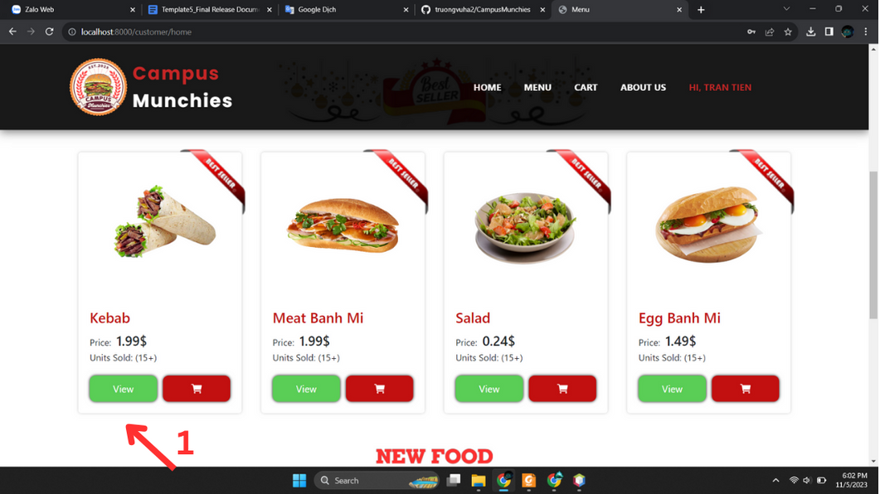

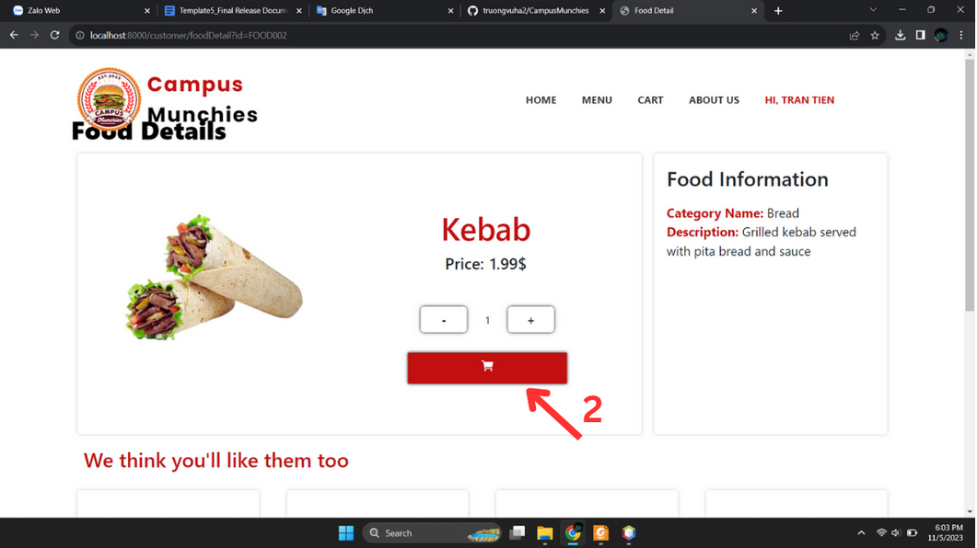

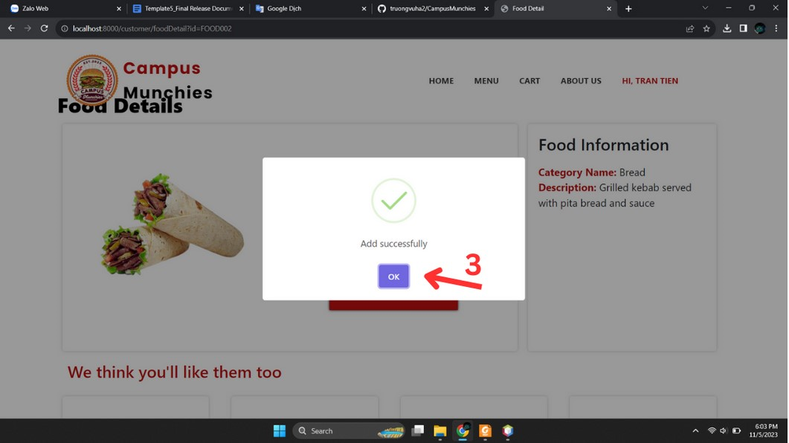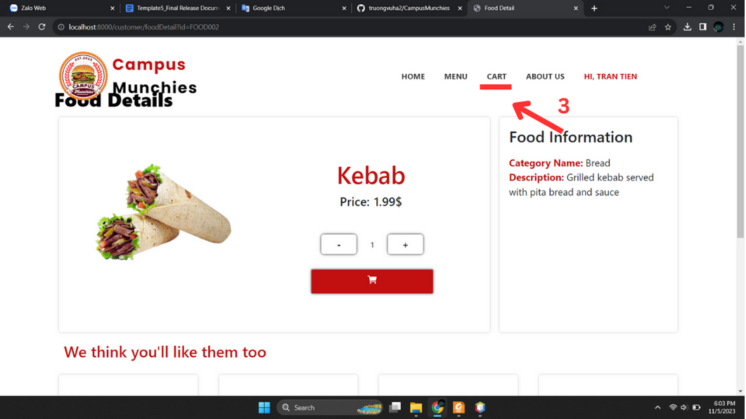

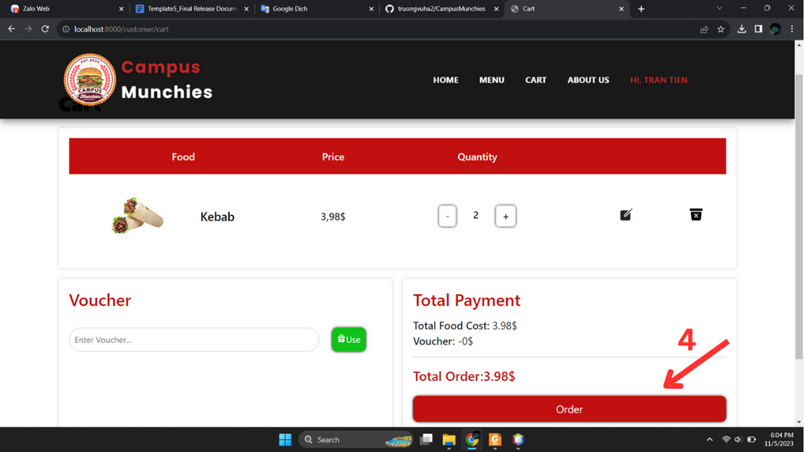

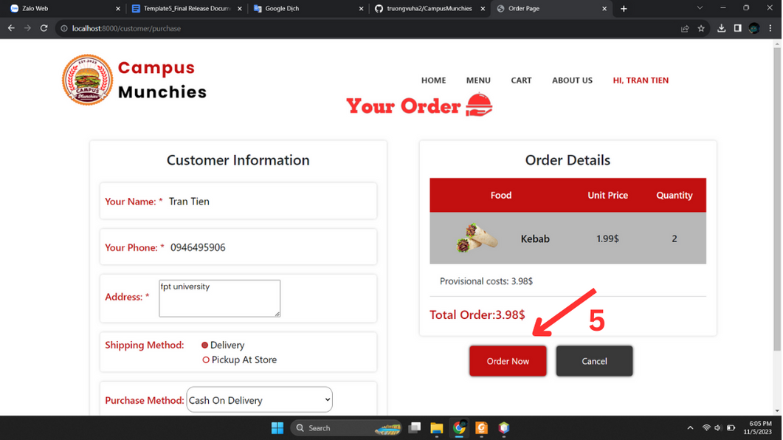

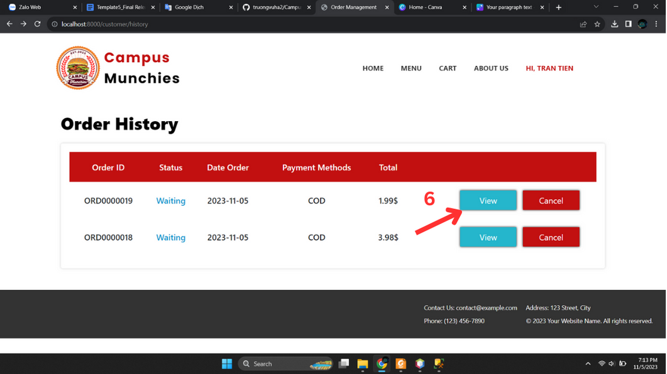

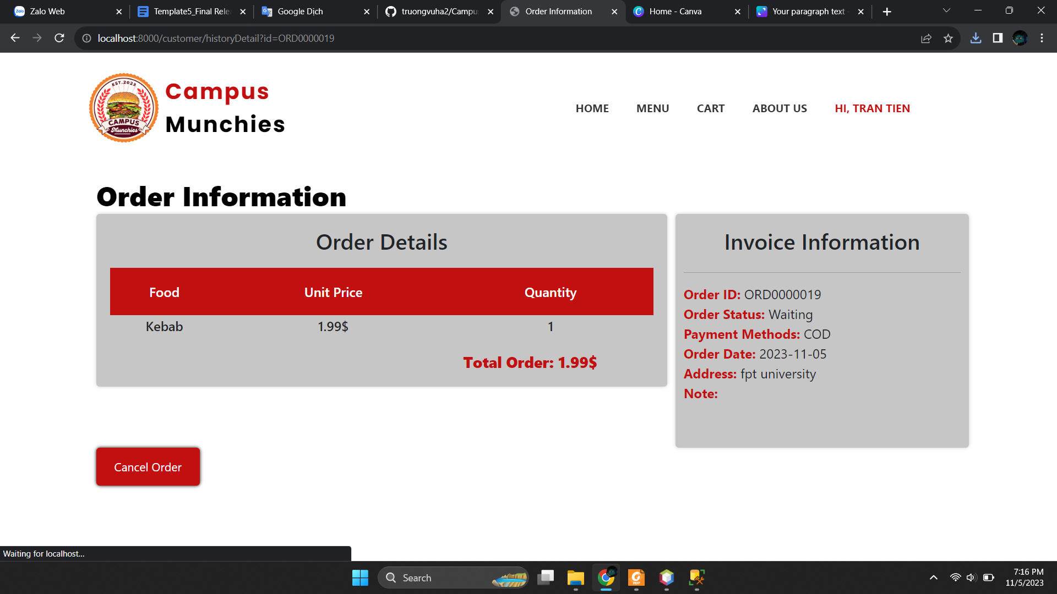

| No. | Function | Description | Validation | Outcome |
| --- | --- | --- | --- | --- |
| 1 | View Food | Click View button | No | Food detail is displayed |
| 2 | Add to cart | Click icon buy | No | Popup is displayed |
| 3 | Show pop up | Add to cart success, popup is displayed | No | Add to cart success |
| 4 | View cart | Click Cart in Menu bar | No | Cart will be displayed |
| 5 | Click order | Click order button to order | No | Order detail will be displayed |
| 6 | Click order now | Click order now button to completely order | No | Order history will be displayed |
| 7 | Click view | Click view button | No | Order details will be displayed |

## 3. View Information Management for Managers

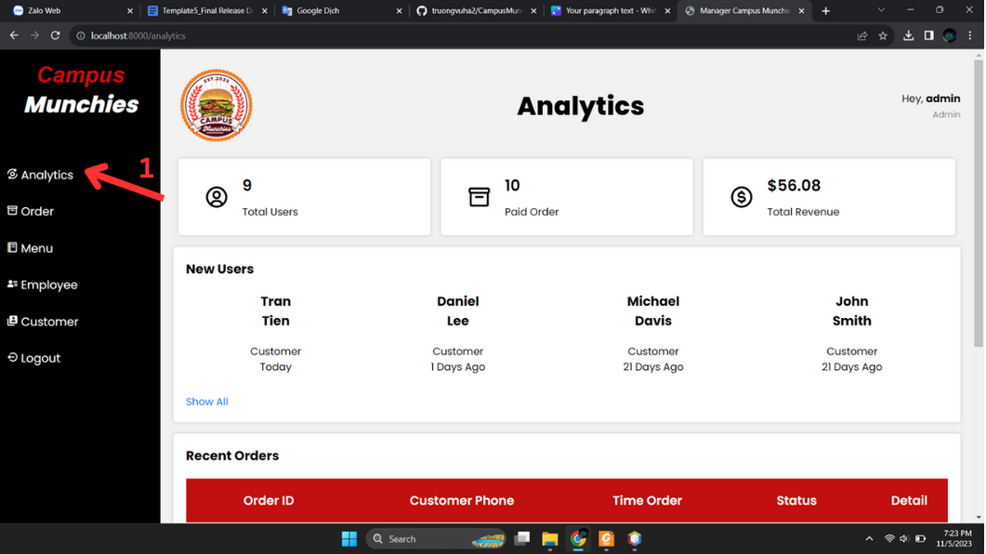

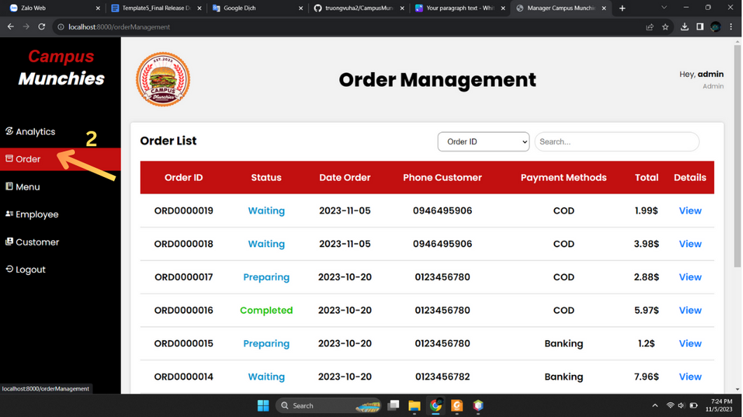

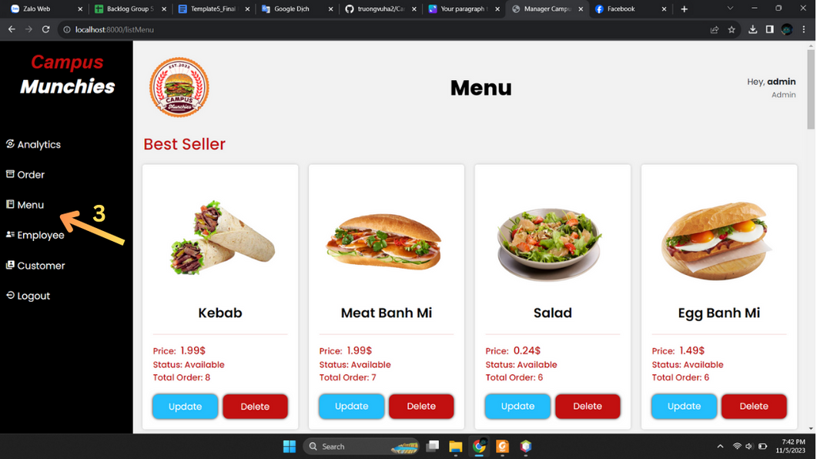

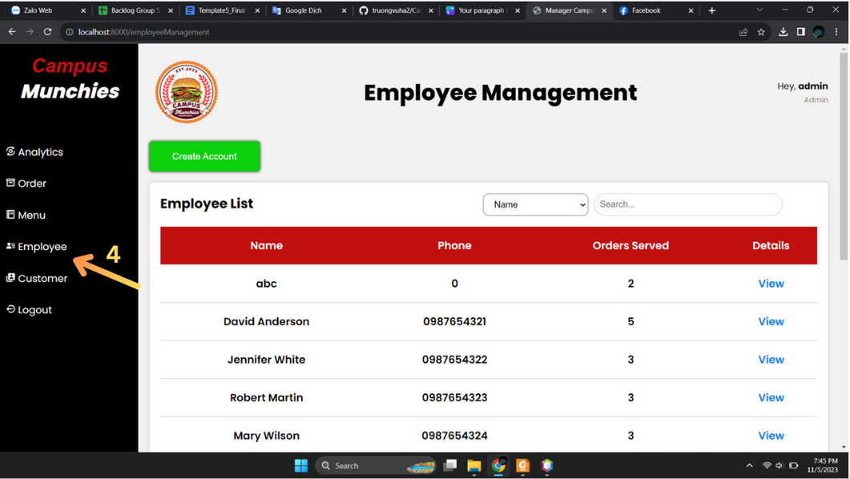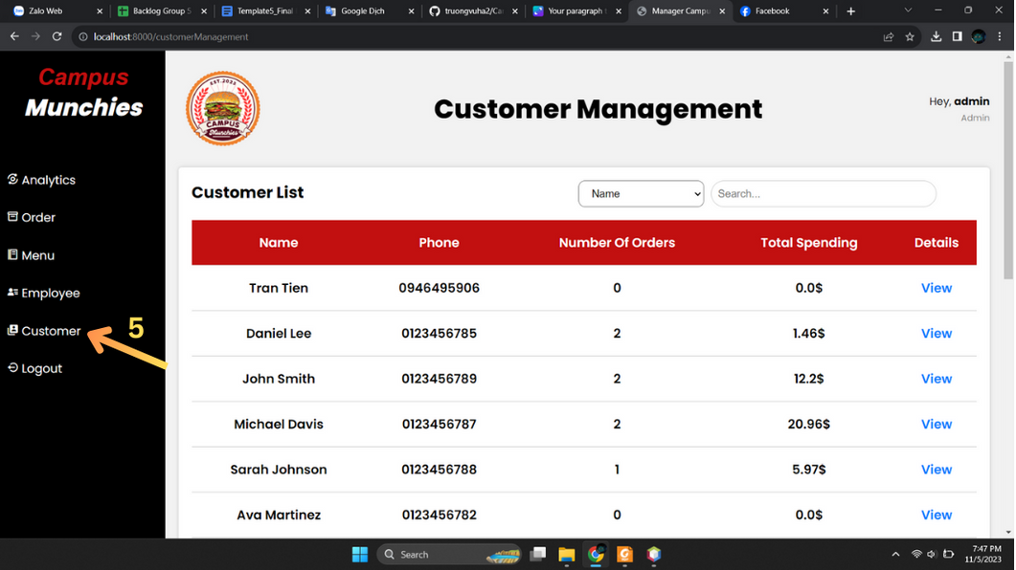

| No. | Function | Description | Validation | Outcome |
| --- | --- | --- | --- | --- |
| 1 | Click analytics | Click Analytics in sidebar | No | Analytics is displayed |
| 2 | Click order | Click Order in sidebar | No | Order manager is displayed |
| 3 | Click menu | Click Menu in sidebar | No | Menu is displayed |
| 4 | Click employee | Click Employee | No | Employee manager is displayed |
| 5 | Click customer | Click Customer in sidebar | No | Customer manager is displayed |

## 4. Change status order for Employee

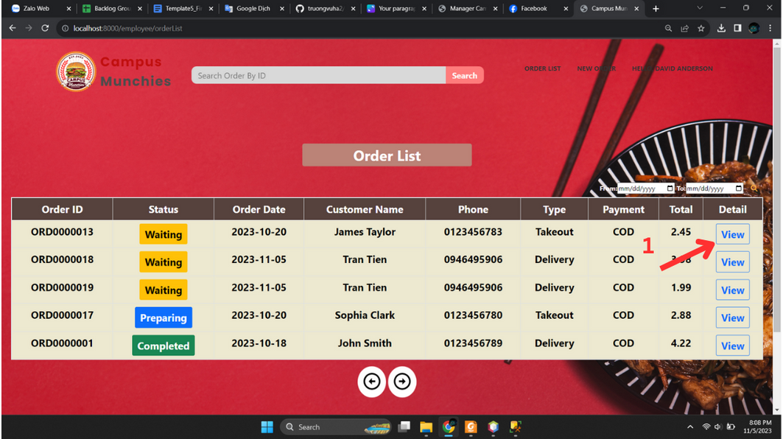

## 

## 

| No. | Function | Description | Validation | Outcome |
| --- | --- | --- | --- | --- |
| 1 | Click View | Click View button | No | Order details is displayed |
| 2 | Click radio | Click radio to set status | No | Radio which is chosen is displayed |
| 3 | Click update | Click update | No | Order change status |

## 5. Check Order for Employee

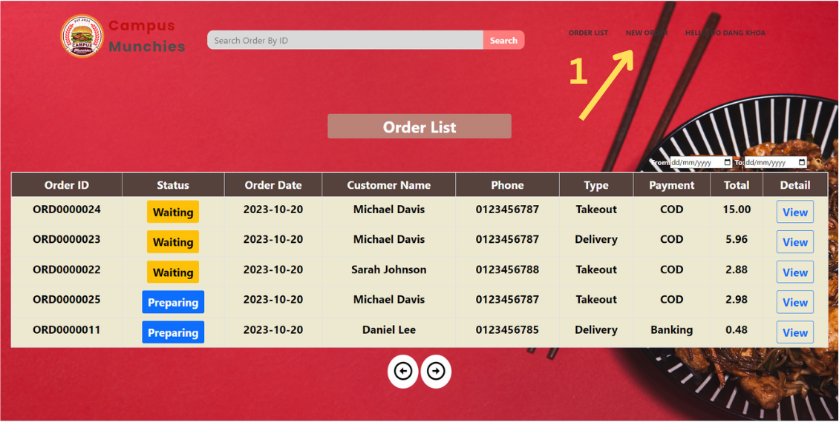

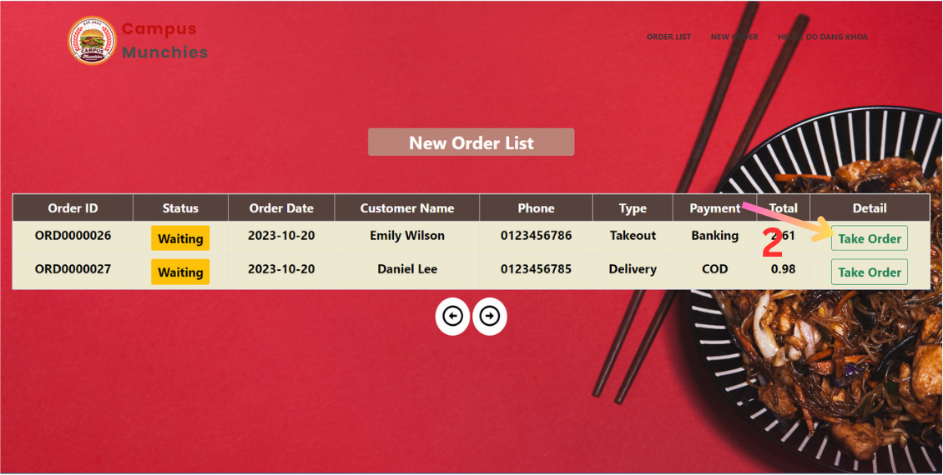

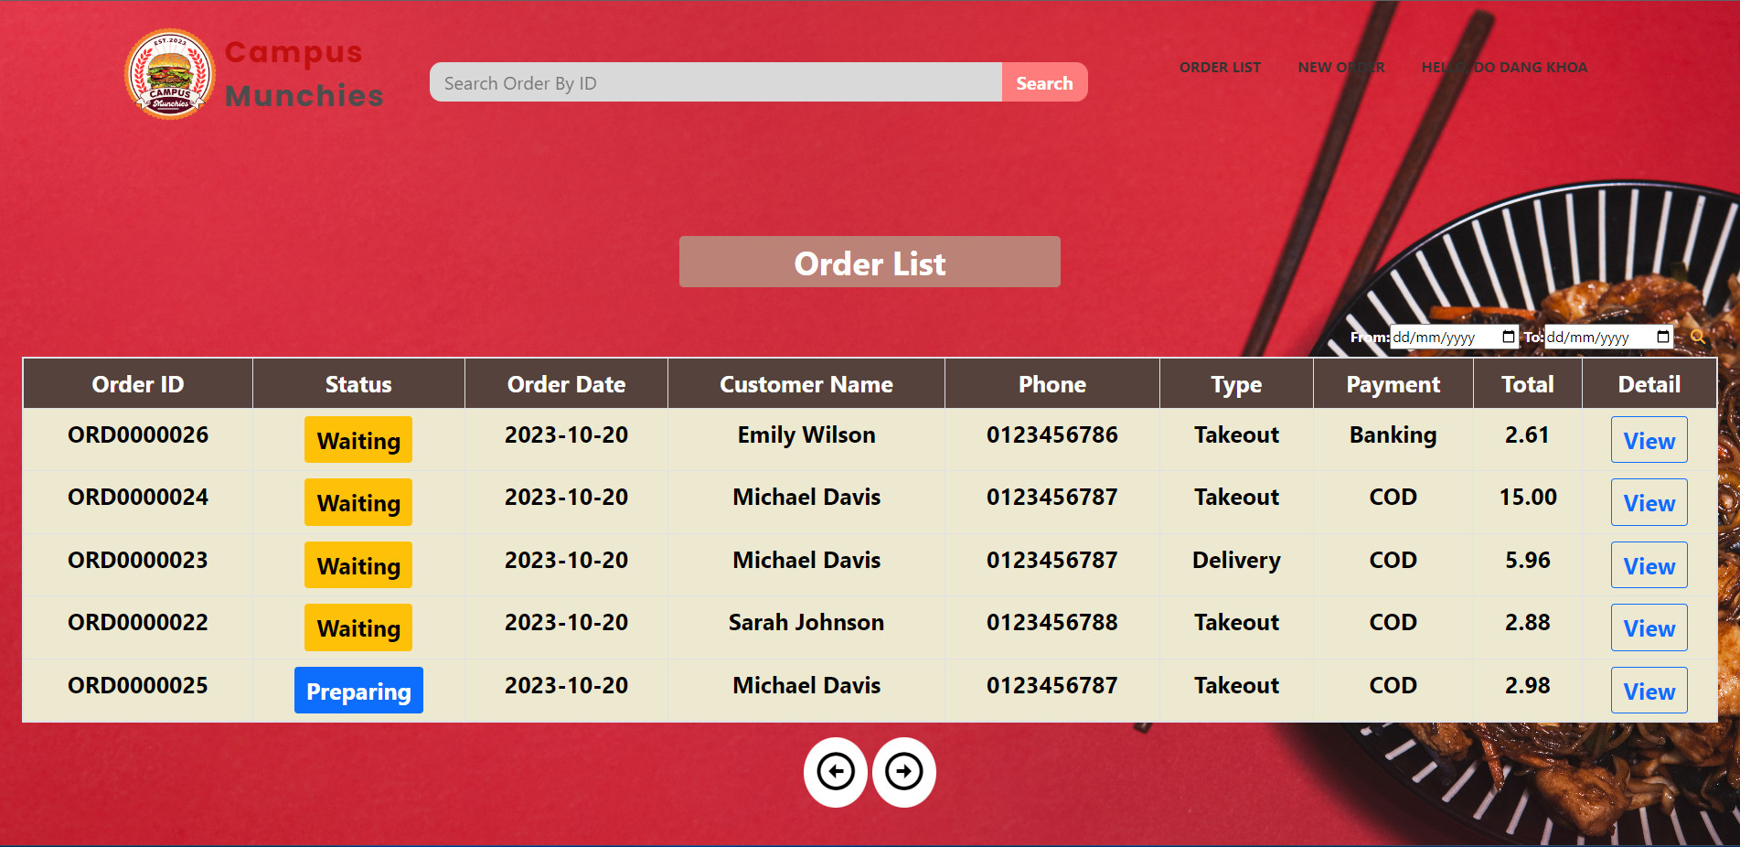

| No. | Function | Description | Validation | Outcome |
| --- | --- | --- | --- | --- |
| 1 | Click New order | Click Click new order menubar | No | New order list is displayed |
| 2 | Click Take order | Click Take order button | No | Order list is displayed |

## 

## 

## 

## 6. Create account for Manager

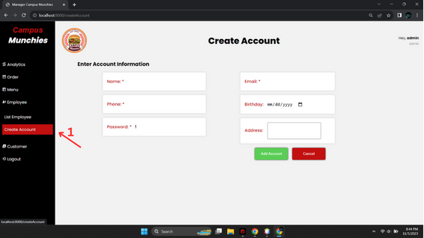

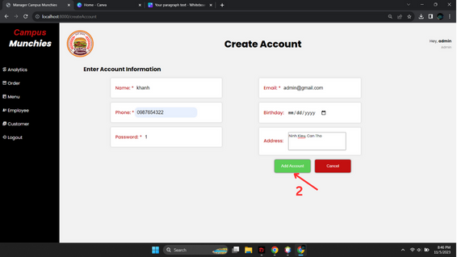

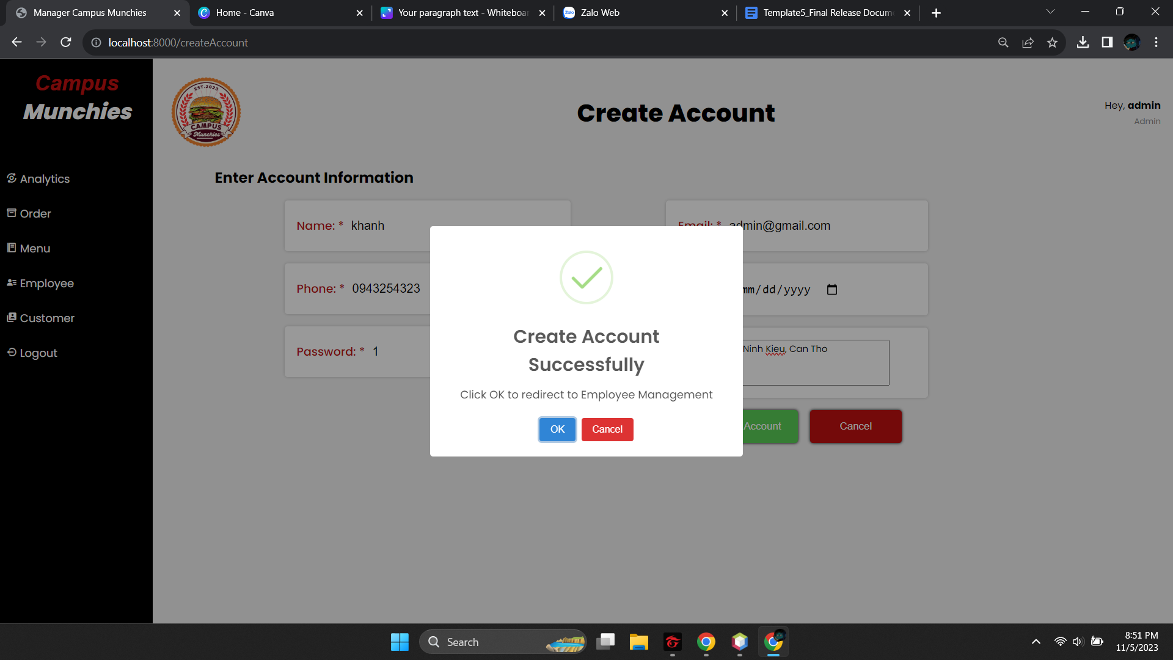

| No. | Function | Description | Validation | Outcome |
| --- | --- | --- | --- | --- |
| 1 | Click Create Account | Click Create Account | No | Create account is displayed |
| 2 | Fill input and click Update | Fill input and click Update button | No | Update successful |

## 

## 7. Add food for Manager

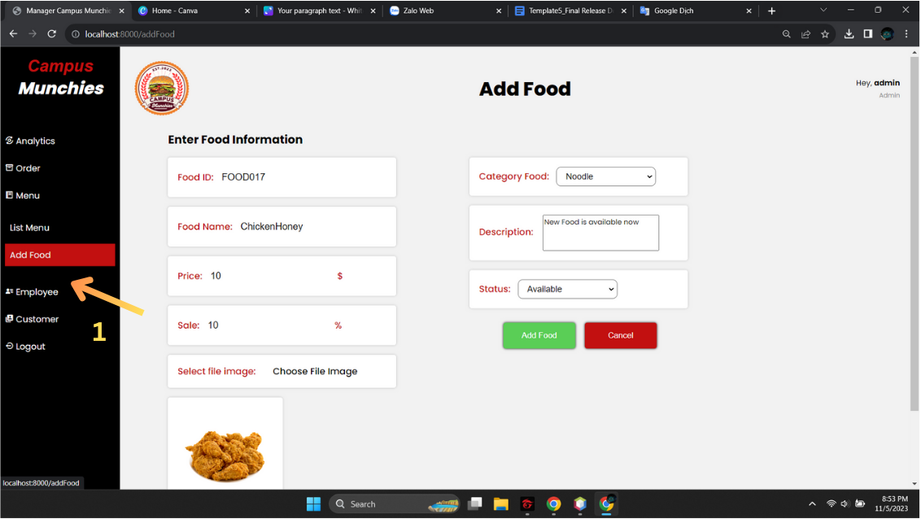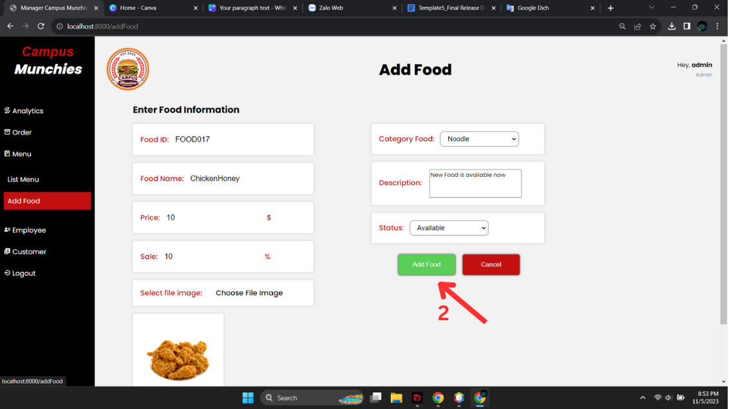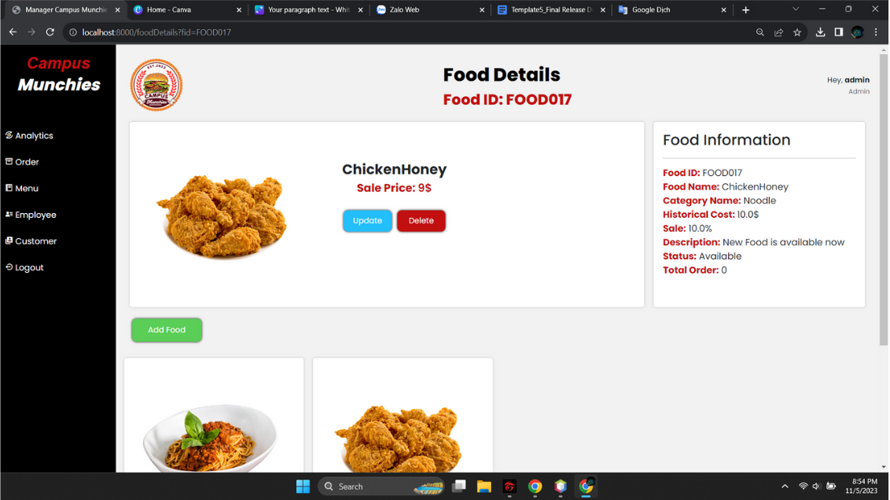

| No. | Function | Description | Validation | Outcome |
| --- | --- | --- | --- | --- |
| 1 | Click Add food | Click Add food | No | Food details is displayed |
| 2 | Fill all input and click Add food | Fill input and click Add food button | No | Show food add in food details |

## 8. Update food for Manager

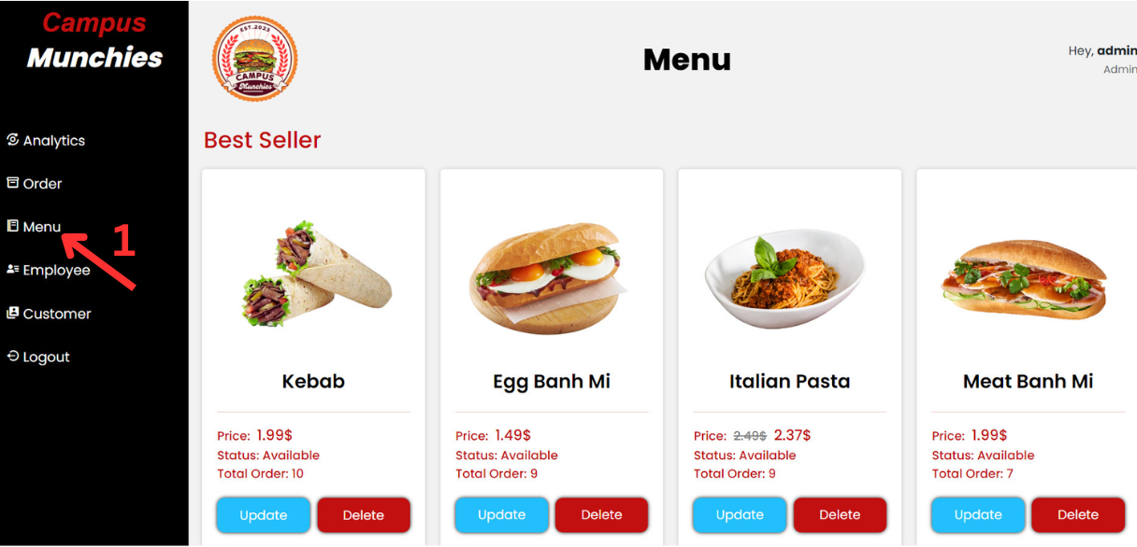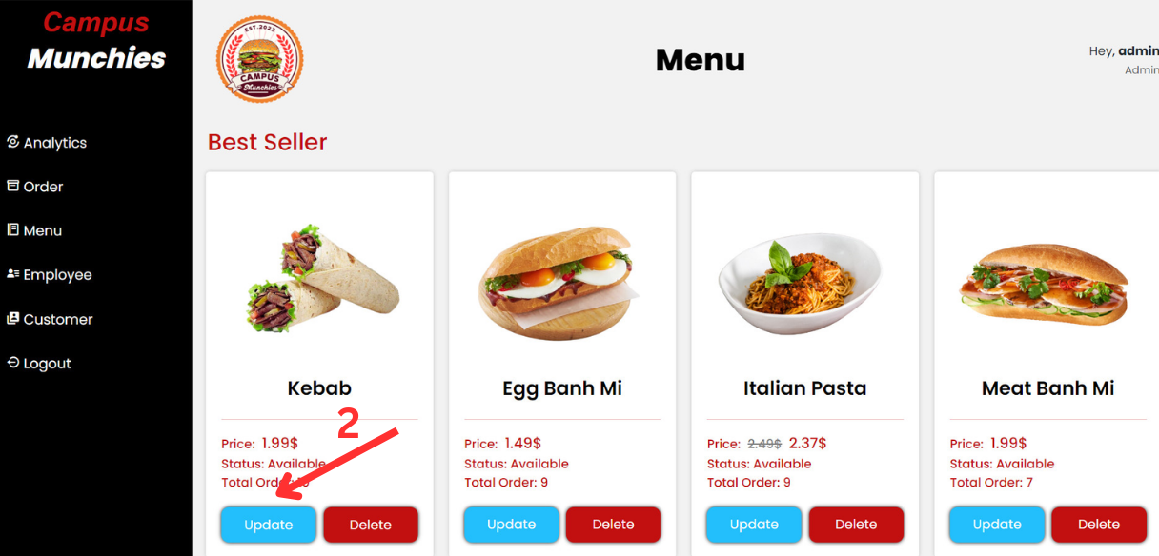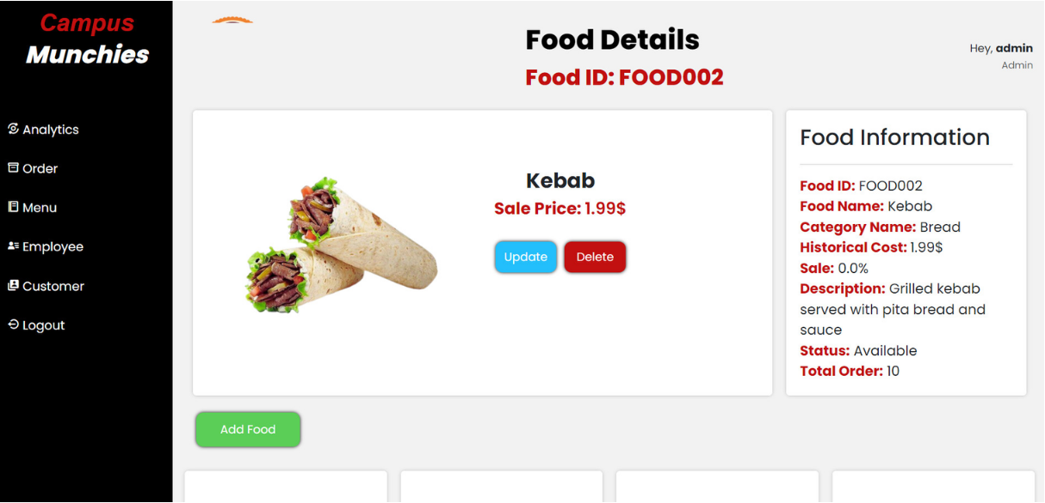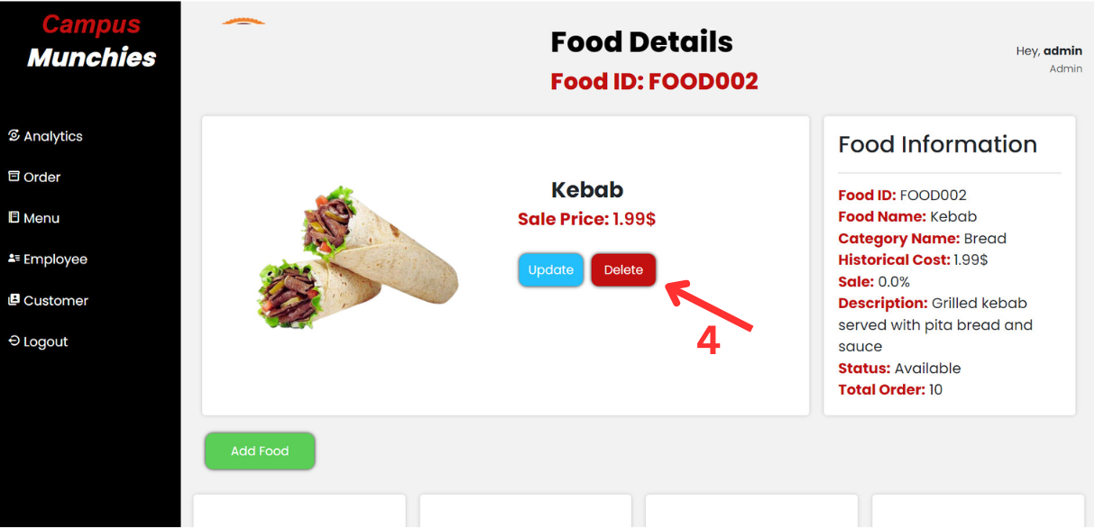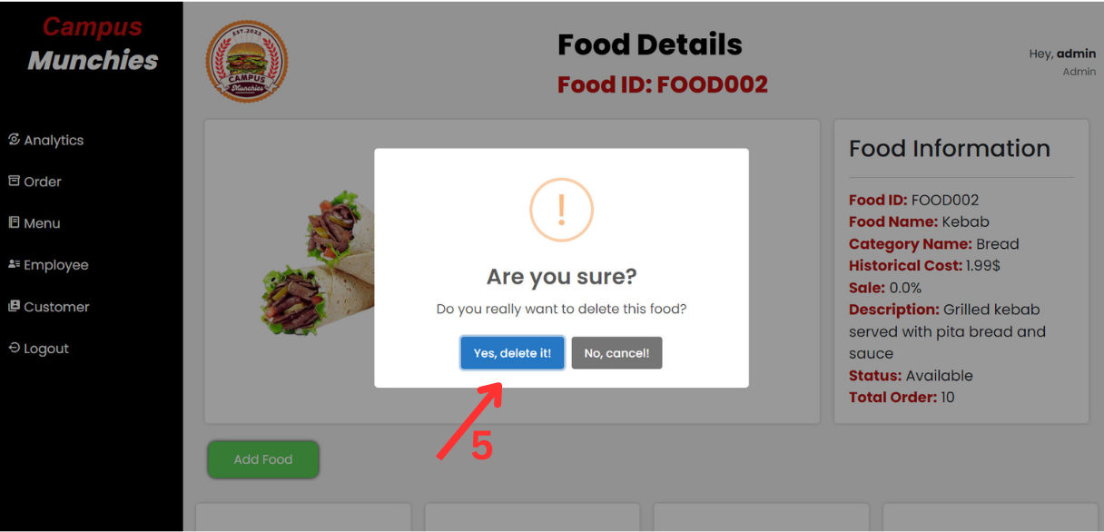

| No. | Function | Description | Validation | Outcome |
| --- | --- | --- | --- | --- |
| 1 | Click Menu | Click Menu in sidebar | No | Menu is displayed |
| 2 | Click update | Click update Button | No | Show food update |
| 3 | Click Update | Click Update button after fill in all input | No | Show food detail |
| 4 | Click Delete | Click Delete button | No | Show popup Delete |
| 5 | Click Yes | Click Yes button | No | Delete food |

## 

## 9. Modify status customer for Manager

## 

| No. | Function | Description | Validation | Outcome |
| --- | --- | --- | --- | --- |
| 1 | Click Customer | Click Customer in sidebar | No | Customer Management is displayed |
| 2 | Click View | Click view Button | No | Show customer details |
| 3 | Click Block | Click Block button | No | Block customer and show Unlock |
| 4 | Click Cancel | Click Cancel in popup | No | Close popup |
| 5 | Click Delete | Click Delete button | No | Delete customer |
| 6 | Click Cancel | Click Cancel in popup | No | Close popup |
| 7 | Click Unlock | Click unlock popup | No | Unblock customer and block is displayed |
| 8 | Click Cancel | Click Cancel in popup | No | Close popup |

## 

## 10. Delete account for Manager

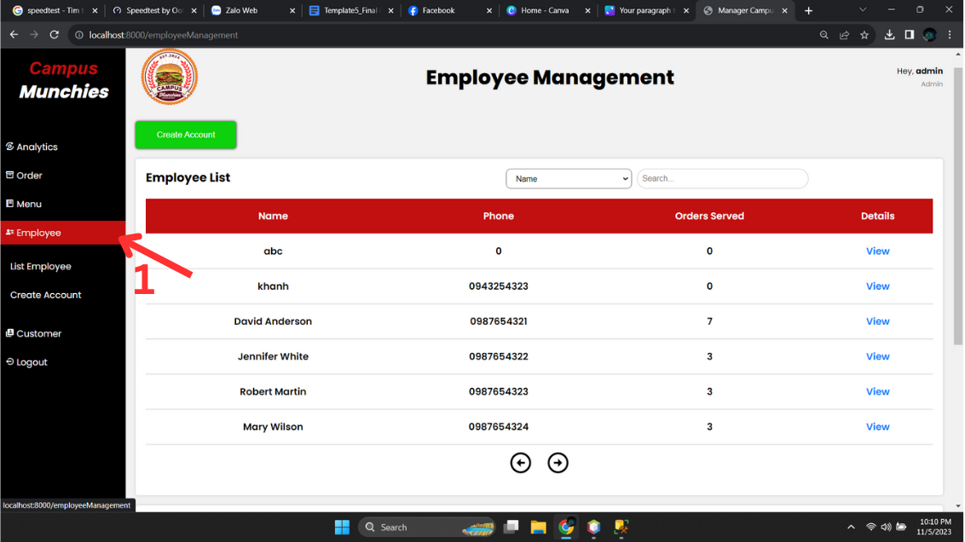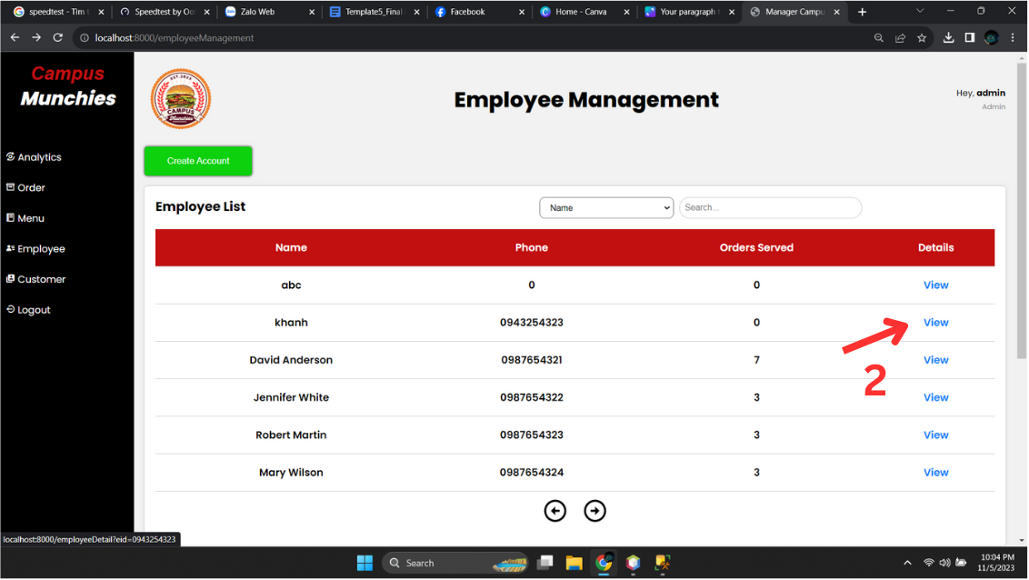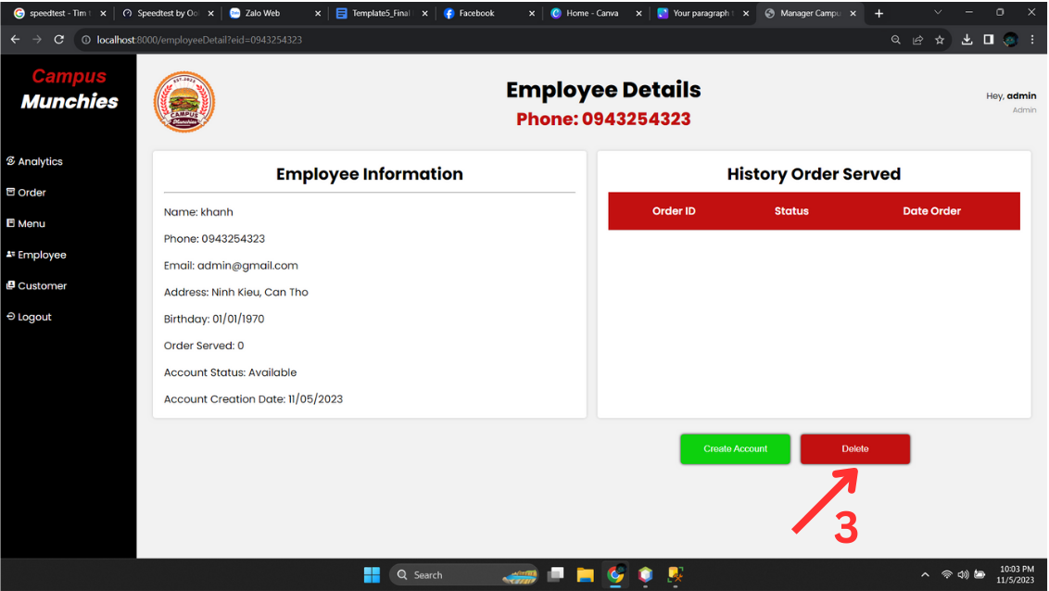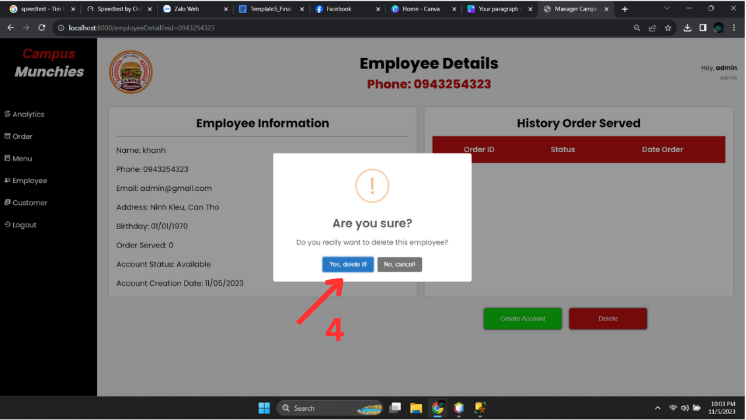

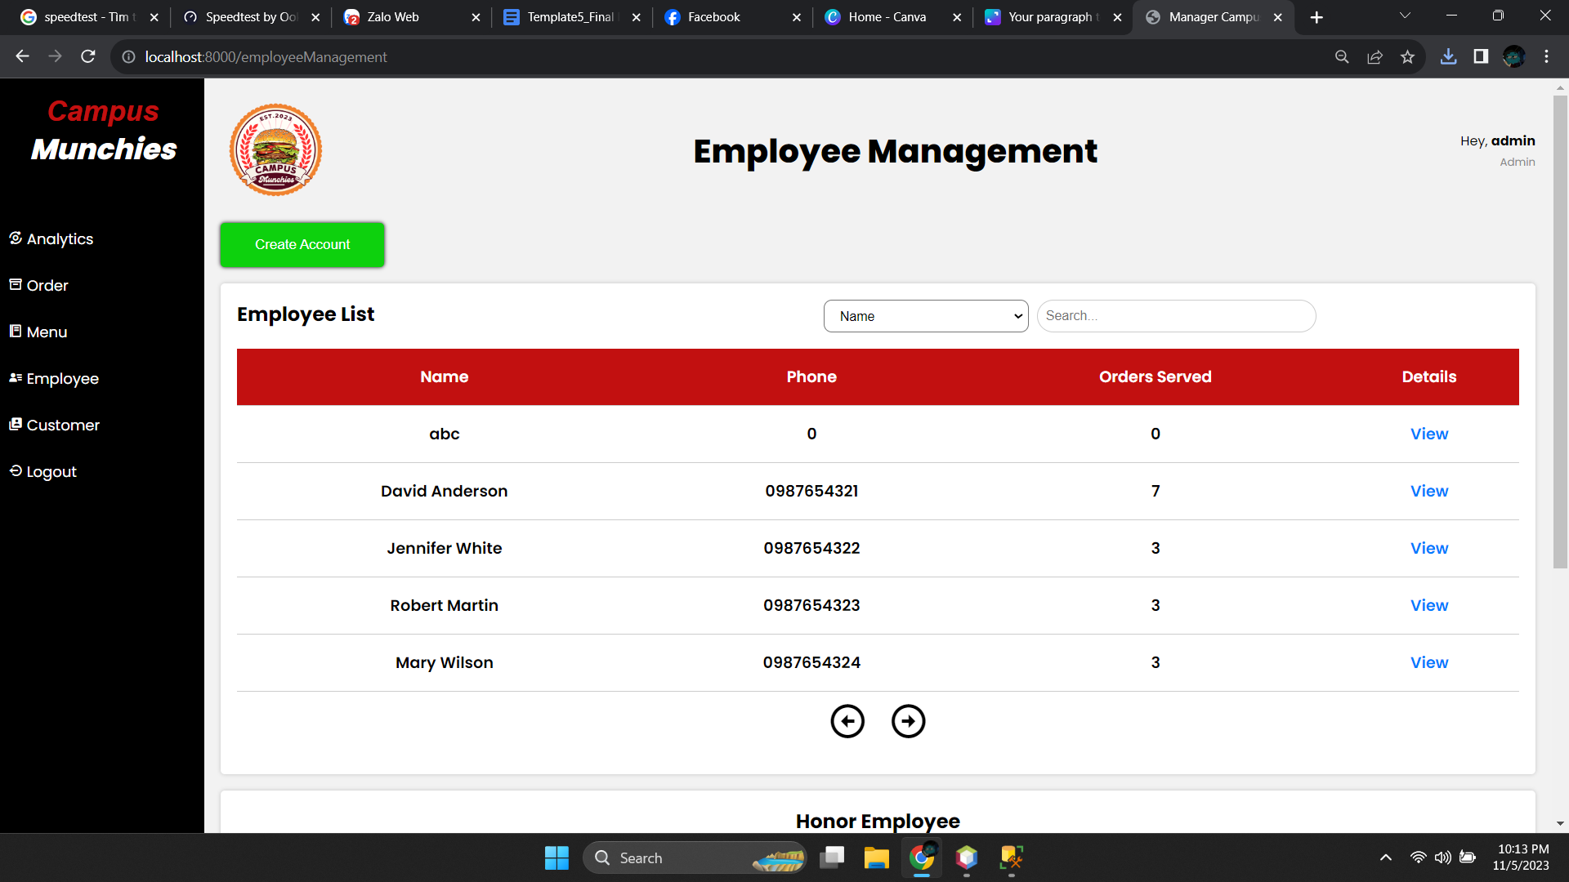

| No. | Function | Description | Validation | Outcome |
| --- | --- | --- | --- | --- |
| 1 | Click List Employee | Click Employee in sidebar | No | Employee Management is displayed |
| 2 | Click View | Click view Button | No | Show customer details |
| 3 | Click Delete | Click Delete button | No | Show popup Delete account |
| 4 | Click Yes | Click Yes button | No | Delete account and show Employee Management |

## 

## 11. Login for Guest

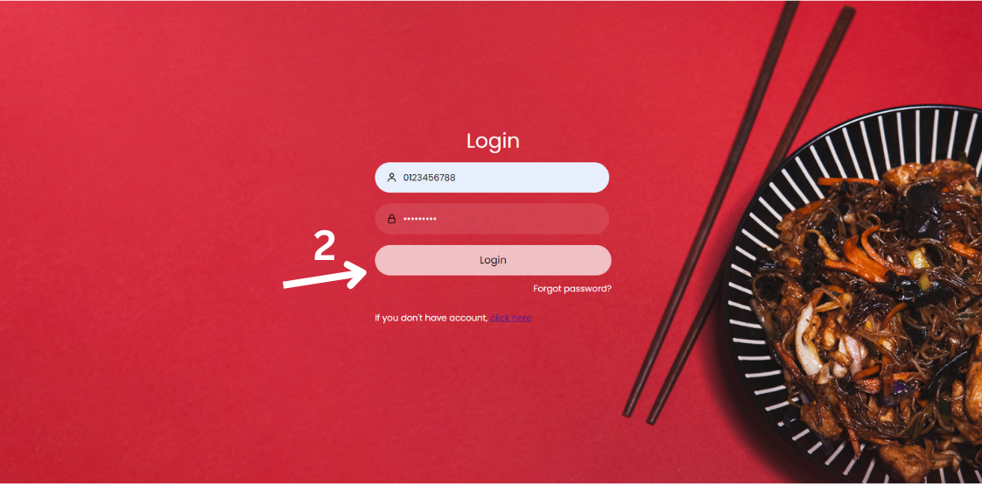

## 

| No. | Function | Description | Validation | Outcome |
| --- | --- | --- | --- | --- |
| 1 | Click Login | Click LogIn sidebar | No | Login form is displayed |
| 2 | Click Login | Fill all input and click login | Yes | Show home |

## 

## 

## 12. Register for Guest

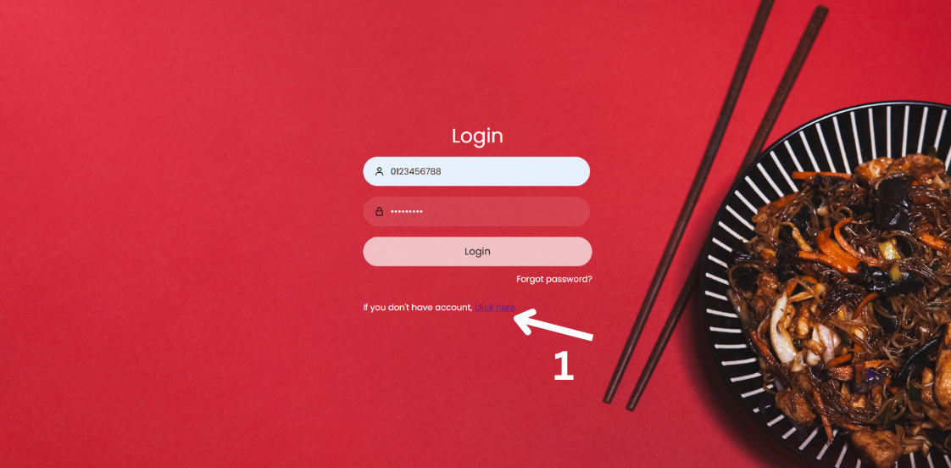

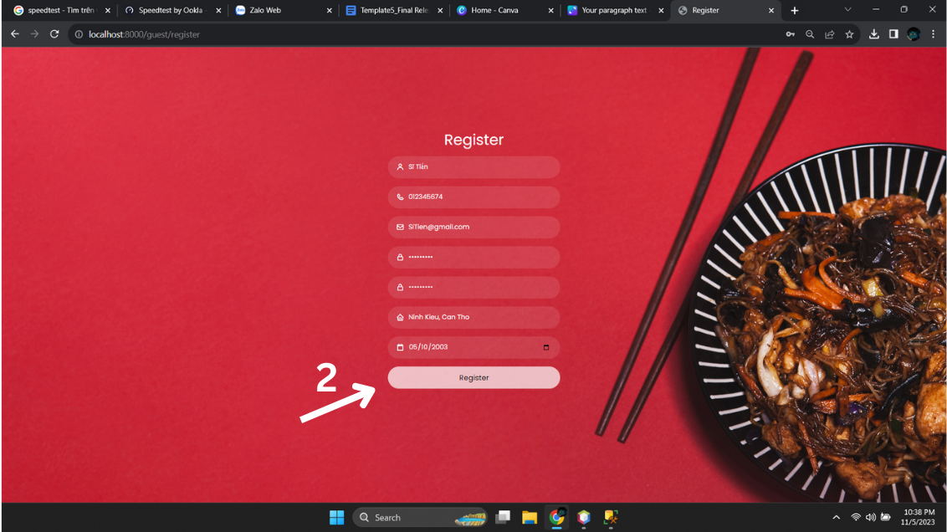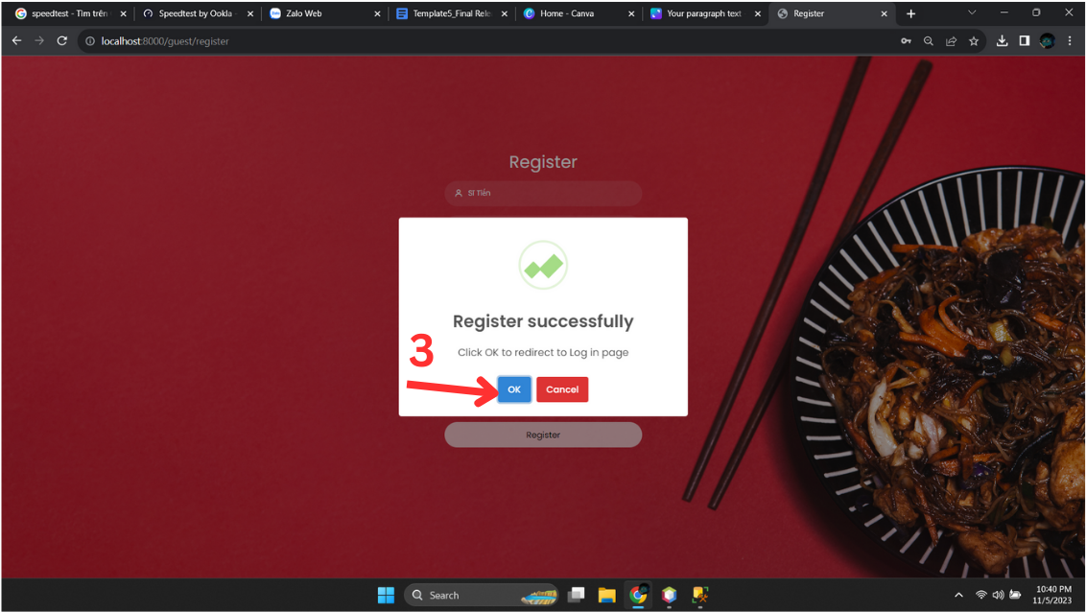

| No. | Function | Description | Validation | Outcome |
| --- | --- | --- | --- | --- |
| 1 | Click “click here” | Click “click here” login page | No | Register form is displayed |
| 2 | Click Register | Fill all input and click register | No | Show popup |

## 

## 13. Forgot password

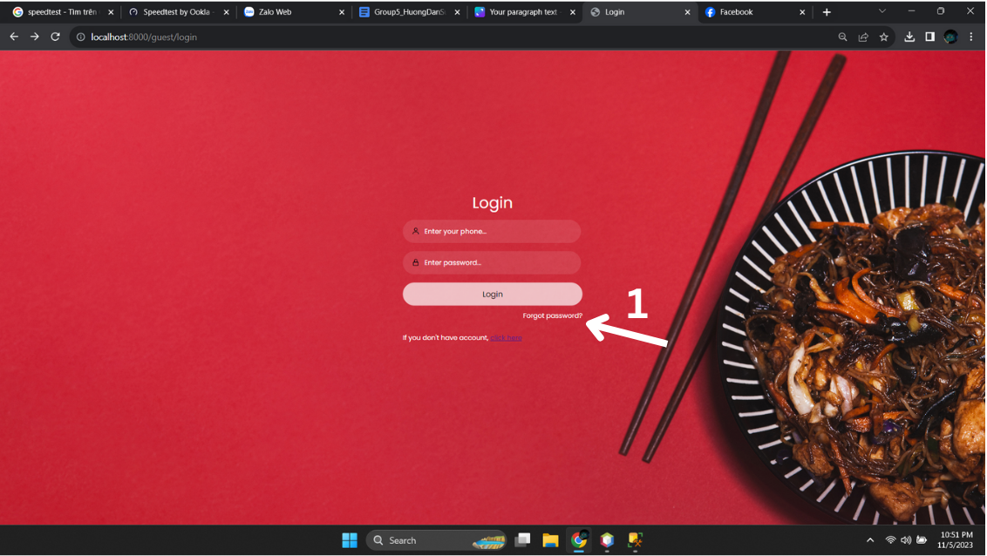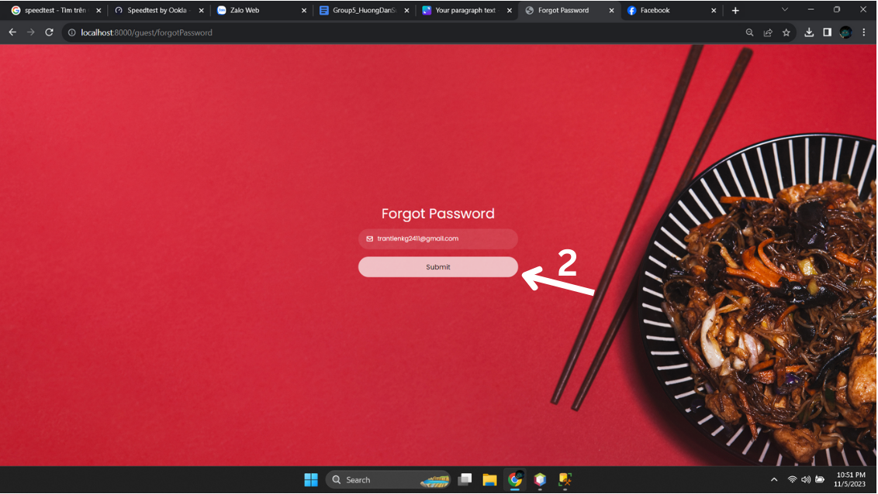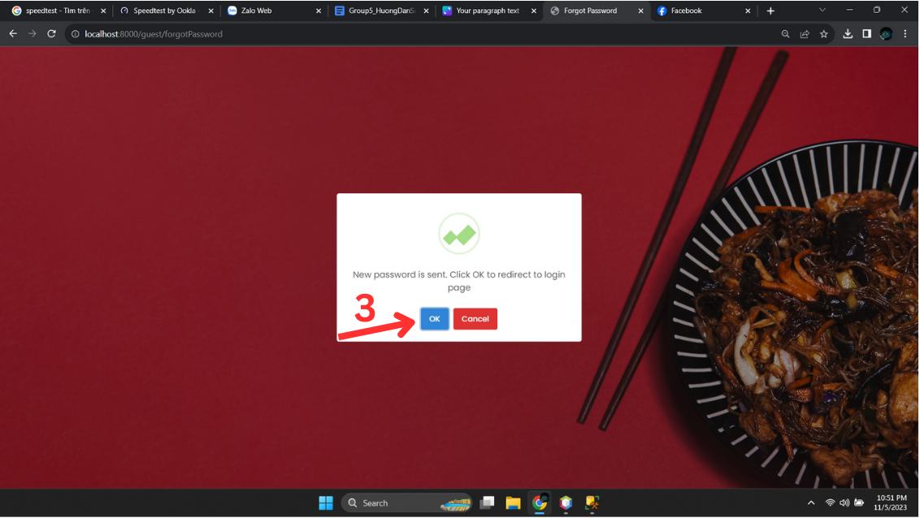

| No. | Function | Description | Validation | Outcome |
| --- | --- | --- | --- | --- |
| 1 | Click Forget password | Click forget password | No | Forget password form is displayed |
| 2 | Click submit | Fill email and click submit | No | Show popup |
| 3 | Click Ok | Click ok in popup | No | Send message email |

## 